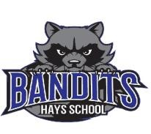
2015-2016
Annual Education Results Report
Horizon School Division No. 67
Combined 2017-2020 Education Plan and
Hays School

An inclusive learning community that engages and empowers all learners for success.

Foundation Statements
Vision

Passionately engaged learners who confidently pursue continual improvement now and, in the future, as contributing global citizens.

Mission Statement

Horizon is a 21st century inclusive learning community that engages and empowers all learners for success.

Our Priorities
Horizon School Division Core Goal
- All learners leaving school are competent contributing global citizens.

Aligns with Provincial Desired Outcomes:
- Alberta’s students are successful
- The achievement gap between First Nations, Métis and Inuit students and all other students is eliminated
- Alberta’s education system is inclusive
- Alberta has excellent teachers, school and school authority leaders
- The education system is well governed and managed
- Complete Project based curriculum with Kindergarten to grade 4 essential understandings.

Principal’s Message
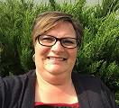

Hays School provides educational opportunities for 57 students from Pre-Kindergarten through Grade 9. Our four teachers, myself, two support staff, librarian and secretary are deeply committed to enhancing our students’ desire for lifelong learning and developing and growing relationships within the Hays community. Our combined grade classes foster a culture of caring and empathy and feature very attractive student to teacher ratios. As a staff, we actively seek opportunities for our students to participate in extracurricular activities, including athletics, student volunteerism, and personal sense of global awareness (Me to We) and the strengthening of our whole school. Students and staff are working on improving Physical and Mental Wellness.
Over 80% of our students speak English as a second or an additional language. Our diversity has helped us to identify and explore learning opportunities for our students. In addition to leveled literacy intervention, using Fountas and Pinnell resources and theory, we have developed our Collaborative Response Model to discuss and develop strategies for individual students. We have arranged our schedule to accommodate our grade 6 and 9 students in numeracy, as they receive dedicated instructional time in small group environments. We also honor the heritage of many of our students by offering German language instruction one afternoon per week, this is at option time, so core classes are not compromised.
We dedicate time to teaching appropriate social skills and respect for oneself and others in school. These skills are intended to develop socially responsible students. A behavior tracking program assists in developing “good citizens “who will develop into community conscious adults.
Our school has undergone some structural changes with new windows and new outdoor upgrades. The people of Hays and the surrounding area drive and support a vibrant local economy that focuses on the agriculture, oil and gas industries. The area boasts a sophisticated network of canals that provide irrigation for area farmers, and a pipeline network servicing the oil and gas sectors. We take pride in being a rural school that develops and supports individual plans for student growth and development.
Go Bandits Go!
Mrs. Tracey Nadeau
Principal, Hays School
“Improving Tomorrow Through Education Today”
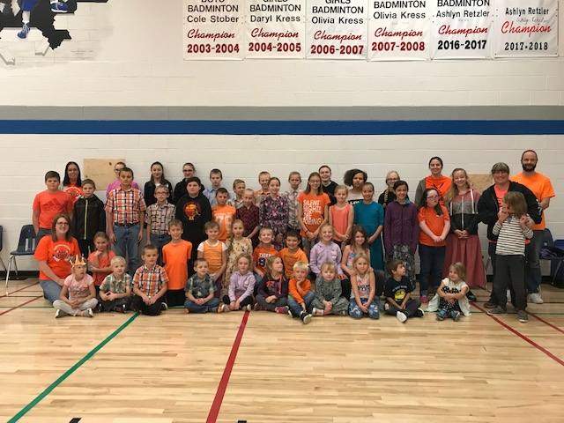
Orange Shirt Day at Hays School- Celebrating all students
Our Success story:
Stude
nts

of Hays School

receive a very high standard
of education. They engage in extra
-
curricular activities
and participate in a variety of special events.

Hays School has a caring parental community that is
dedicated to ensuring that the children of Hays are
provided with quality learning experiences.

The staff of Hays School believes in seeking new and
challenging ways of delivering curriculum rich content

for our students. We offer a better than 1 to 1 ratio of
learning devices per student, and we believe in
ongoing research and professional development that
will continually improve our practice.

With the three main stakeholders working together, we
can allow our students to challenge themselves
in a supportive environment. Together, we lead each
other to greater success.

We have alternate seating in every room and students use stools, standing tables and many other kinds of seating.

Building Our “Tiny House” helps to show students there are many skills we learn in everyday work.

Accountability Pillar Overall Summary Annual Education Results Reports - Oct 2018 School: 6604 Hays School

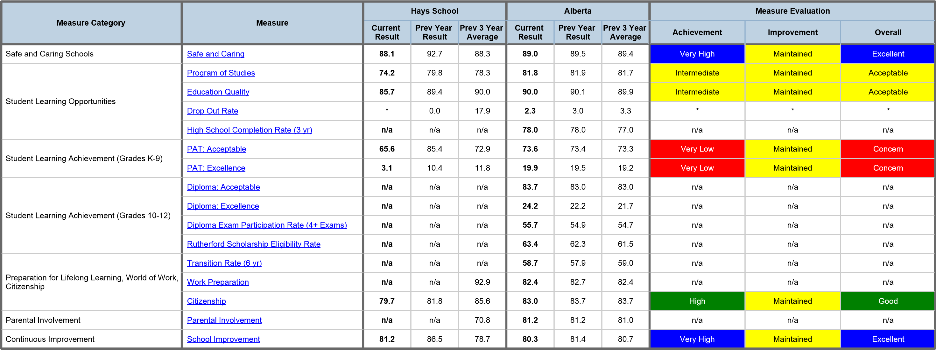

TARGETED AREAS FOR IMPROVEMENT IN 2018-2019

Performance Area | Current Result | Target (2019-2020)
PAT: Acceptable/Excellence | 65.6 /11.8 | 73.3/19.2
Comment on Results:

Hays School has historically shown variation from year to year in this area. Each year, the low number of students taking part in PAT exams, and the proportion of English Language Learners writing the exams varies. We at Hays School have made a commitment to focus on our younger learners, with the intent of building a strong foundation of learning and literacy, regardless of student background.

Strategies:

Fountas and Pinnell assessment and intervention to all learners in grades 1-9.

Increase specific and ongoing reading intervention in grades 1-6.

A renewed emphasis on numeracy at all grade levels, including games 2 days per week for 15 minutes right after lunch.

Individualized strategies discussed at CRM Meetings Monthly.
Performance Area | Current Result | Target (2019-2020)
Parental Involvement | 70 | 81.2
Comment on Results:
Our 3 year average is 70 and we feel we can improve on this by inviting parents into the school

Strategies:
- Bandit Newsletters and frequent updates to the school sign to keep parents in the information loop.
- Updating the school website.
- Inviting parents into the school whenever possible, be it sporting events, celebrations of student learning, or parent council meetings.
- Plan community events that give parents the opportunity to learn alongside their children.
- Frequent tours of the school as evolution in appearance and culture take place.
- Teacher attendance at Parent Advisory Council meetings on a rotating basis.
- Craft and coffee night
Professional Development:
Teachers remain decisive in striving to give of their time to the community in an effort to have a positive impact in the community. This does not show as a monetary support, but to open and improve channels of communication between the community and the school.

SCHOOL IMPROVEMENT AND PROFESSIONAL DEVELOPMENT PLAN

Core Goal - All learners will finish school able to be contributing global citizens who possess the competencies of Engaged Thinkers and Ethical Citizens with an Entrepreneurial Spirit
Key Action 1 - Success for each student through strong core instruction that develops student competencies
(Ministerial Order #001/2013)
Strategies (plan for action) | Timeline (including dates) | Person responsible | Budget Allocation
Joining the We Schools program | Sept-June | Mrs. Nadeau, Mr Kenney, Mrs. Mack, Mr. Poettcker | Parent Council support
Develop options courses that provide challenge and stimulation to junior high students, “Tiny House” Project | Sept-June | Mrs. Nadeau, Mr. Kenney, Mr. Poettcker, Mrs. Duckett | Students writing letters for donations
Key Action 2 - Employing our teaching and learning Response to Instruction and Intervention Framework to improve literacy and numeracy proficiency.
Strategies (plan for action) | Timeline (including dates) | Person responsible | Budget Allocation
Focus on literacy and numeracy daily. | Sept-June | All Staff | None
Complete CRM Meeting | Sept-June | All Staff | None
Key Action 3 - Engaging all stakeholders as student success is everyone’s business.
Strategies (plan for action) | Timeline (including dates) | Person responsible | Budget Allocation
Students will focus on healthy activities with monthly themes to provide healthy alternatives to students. | Sept-June, mid-month | All staff
Developing relationships with parents. Christmas Concert, Missoula Theatre, Mother’s Day Tea, Father’s Day BBQ | Throughout the year | All staff
Support Staff Professional Learning (12 hrs discretionary)
Support staff will have SIVA training. We will seek PD opportunities in literacy. Ensure people have up to date First Aid Training.

