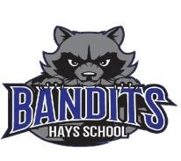

An inclusive learning community that engages
and empowers all learners for success.

20201
-
2021

Annual Education Results Report

Horizon School Division No. 67

Combined 2017
-
Education Plan and
2021

Hays School

Foundation Statements
Vision

Passionately engaged learners who confidently pursue continual improvement now and in the future as contributing global citizens.

Mission Statement

Horizon is a 21st century inclusive learning community that engages and empowers all learners for success.

Our Priorities
Horizon School Division Core Goal
- All learners leaving school are competent contributing global citizens.

Aligns with Provincial Desired Outcomes:
- Alberta’s students are successful
- The achievement gap between First Nations, Métis and Inuit students and all other students is eliminated
- Alberta’s education system is inclusive
- Alberta has excellent teachers, school and school authority leaders
- The education system is well governed and managed
- Complete Project based curriculum with Kindergarten to grade 4 essential understandings.

Principal’s Message

Hays School provides educational opportunities for 43 students from Pre-Kindergarten through Grade 9. Our five teachers, three support staff and the rest of the Hays School team are determined and committed to enhancing our students’ desire for lifelong learning and developing and growing relationships within the Hays community. Our combined grade classes foster a culture of caring and empathy, and feature very attractive student to teacher ratios. As a staff, we actively seek opportunities for our students to participate in extracurricular activities, including cross-country running, volleyball, career fairs, badminton, track and field, basketball as well as field trips to and other activities as they arise. This year 2020-2021 with COVID-19 most of these activities are on hold.
Approximately 75% of our students speak English as a second or as an additional language. Our diversity has helped us to identify and explore learning opportunities for our students. In addition to leveled literacy intervention, using Fountas and Pinnell resources we are conducting CRM meetings to discuss and try strategies and re-evaluate and change programs for individual students on a regular basis. Hays School has arranged our schedule to accommodate our grade 6 and 9 students in numeracy, as they receive dedicated instructional time in small group environments. We also honor the heritage of many of our students by offering German Language instruction one afternoon per week on Mondays. We have our options at this time so students are not missing Core Classes.
Our school has undergone many exciting changes in recent months, both in staffing and in appearance. The Hays community and the Parent Advisory Association (School Council) have been very supportive toward our new team members and our initiatives. We are making a conscious and consistent effort to make Hays School a vital and integral part of the local community, both now and for the future.
The people of Hays and the surrounding area drive and support a vibrant local economy that focuses on the agriculture and oil and gas industries. The area boasts a sophisticated network of canals that provide irrigation for area farmers, and a pipeline network servicing the oil and gas sectors and now a very vibrant Solar Power Industry. The support from the community for the building of our “Tiny House Project” has been exceptional. Many people in the Hays Community and Taber have been supportive of helping our school complete the project by money donations and by donating supplies for use to build the “Tiny House”. We are blessed to live in such a great community.

Tracey Nadeau
Principal Hays School

What makes us Hays School
“Improving Tomorrow Through Education Today”
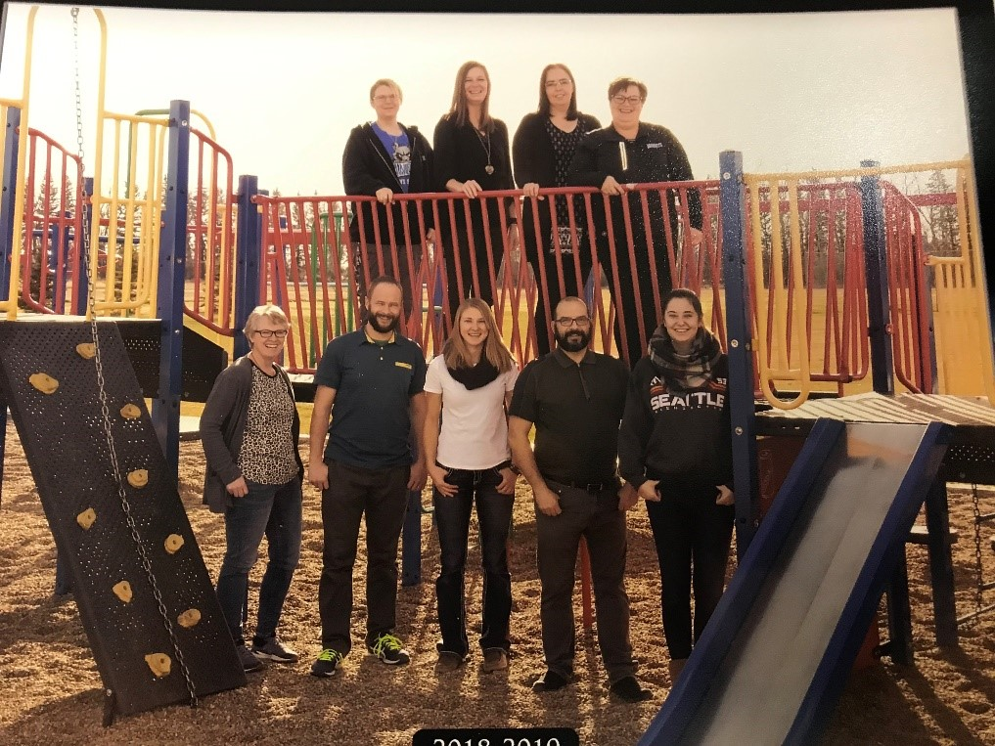
2018-2019 Staff Photo

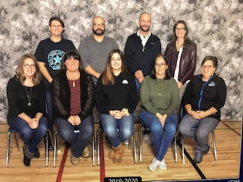

Staff Photo 2019-2020

NO PHOTO FOR 2020-2021 COVID-19 RULES (We welcome Monique Huvenaars back to our staff- filling in for Mrs. Howg who is on maternity leave, We also welcome Mariann Bierman and Mary Elias to our support staff)

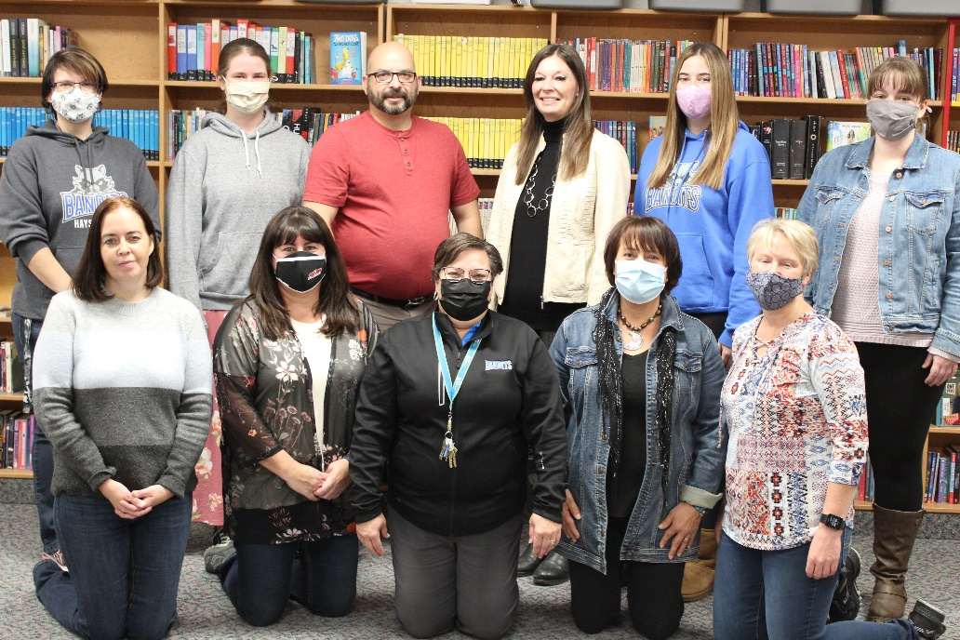

Hays School has a small shed that we are now using to operate shop classes. Our options classes now focus on using power tools, cooking classes, year book, leather work and special projects.

With the curriculum changes we are moving to Project Based Learning. We have started on our journey towards using Essential Understandings and creating competencies in our core subjects, collaboratively covering may learning outcomes over many subjects in one project. At each of our monthly staff meetings we focus on one new aspect to help us with Project Based Learning.

Hays School operates on a foundation of respect, caring and supporting others. Our staff and Parent Advisory Association support our students and their activities, and our students support and take care of each other.

Our population is diverse, and our students are keenly aware of different cultures. Our team works together learning new and forward thinking techniques to teach our Hays population.

Our Success story: | 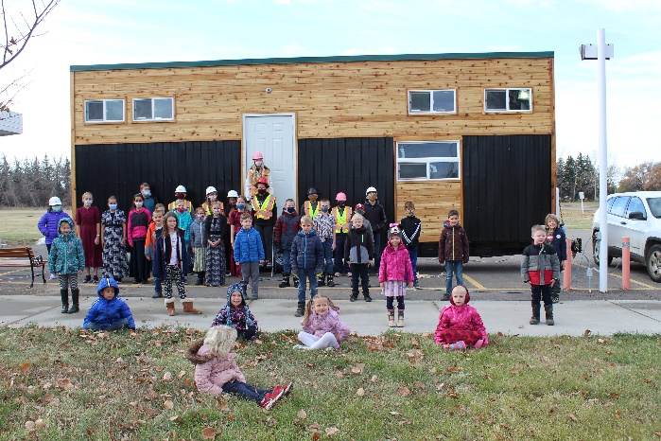  receive a very  high standard  All students who worked on it.  Upper loft above the kitchen.  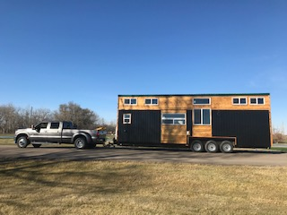  Tiny House SOLD to Don and Tracey  Mackenzie- Grieve. Thank you for Supporting  Hays School.

Our “Tiny House” Project 2018-2020

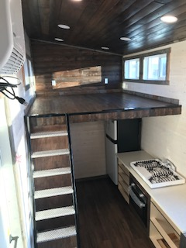
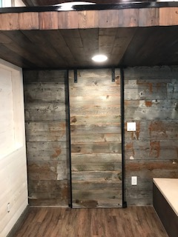
Our Feature wall turned out great!

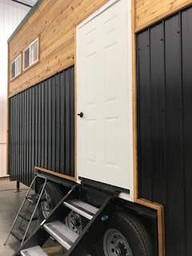

The front door
and steps.
Our Success story

Combined 2015 Accountability Pillar Overall Summary
Measure Category | Measure  Category  Evaluation | Measure | Hays School |  |  | Alberta |  |  | Measure Evaluation
 |  |  | Current Result | Prev ^{Year}  Result | Prev 3 Year  Average | Current Result | Prev ^{Year}  Result | Prev 3 Year  Average | Achievement | Improvement |  | Overall
Safe and Caring Schools | Excellent | Safe and Caring | 93.3 | 78.9 | 83.3 | 89.5 | 89.2 | 89.1 | Very High | Improved |  | Excellent
Student Learning Opportunities | n/a | Program of Studies | 82.9 | 72.4 | 69.9 | 81.9 | 81.3 | 81.4 | Very High | Maintained |  | Excellent
 |  |  |  |  |  |  |  |  |  |  |  | Excellent
 |  | Education Quality | 93.8 | 86.7 | 87.8 | 90.1 | 89.5 | 89.5 | Very High | Maintained
 |  | Drop Out Rate | * | 35.8 | 16.2 | 3.2 | 3.5 | 3.5 | * | * |  | *
Student Learning  Achievement (Grades K9) | Concern | PAT: Acceptable | 65.0 | 68.2 | 77.7 | 73.6 | 72.9 | 73.4 | Very Low | Maintained |  | Concern
 |  | PAT: Excellence | 6.7 | 18.2 | 17.0 | 19.4 | 18.8 | 18.6 | Very Low | Maintained |  | Concern
Preparation for Lifelong  Learning, World of Work,  Citizenship | n/a | Work Preparation | 100.0 | 85.7 | 92.9 | 82.6 | 82.0 | 81.1 | Very High | Maintained |  | Excellent
 |  | Citizenship | 87.6 | 87.5 | 85.9 | 83.9 | 83.5 | 83.4 | Very High | Maintained |  | Excellent
Parental Involvement | Issue | Parental Involvement | 74.1 | 67.6 | 80.3 | 80.9 | 80.7 | 80.5 | Low | Maintained |  | Issue
Continuous Improvement | Excellent | School Improvement | 98.9 | 50.6 | 58.8 | 81.2 | 79.6 | 80.0 | Very High | Improved Significantly |  | Excellent

Notes:
- Current and historical results have been adjusted to reflect the change from previous data source systems to Provincial Approach to Student Information (PASI).
- Due to the change from previous data source systems to Provincial Approach to Student Information (PASI), historical Rutherford Scholarship Eligibility Rate results are not available.
- Aggregated PAT and Diploma results are a weighted average of percent meeting standards (Acceptable, Excellence) on Provincial Achievement and Diploma Examinations. The weights are the number of students writing the Examination for each course.
- Overall evaluations can only be calculated if both improvement and achievement evaluations are available.
- Please note that participation in Grade 9 Provincial Achievement Tests was substantially impacted by the flooding in June 2013. Caution should be used when interpreting trends over time for the province and those school authorities affected by the floods.
- Please note that participation in Diploma Examinations was impacted by the flooding in June 2013. Caution should be used when interpreting trends over time for the province and those school authorities affected by the floods.
- Survey results for the province and school authorities were impacted by the changes in the number of students responding to the survey through the introduction of the OurSCHOOL/TTFM (Tell Them From Me) survey in 2014.
- Data values have been suppressed where the number students is less than 6. Suppression is marked with an asterisk (*).

TARGETED AREAS FOR IMPROVEMENT IN 2016-2017
Performance Area | Current Result | Target (2016-17)
PAT: Acceptable/Excellence | 65.0/6.7 | 75/15
Comment on Results:

Hays School has historically shown variation from year to year in this area. Each year, the low number of students taking part in PAT exams, and the proportion of English Language Learners writing the exams varies. We at Hays School have made a commitment to focus on our younger learners, with the intent of building a strong foundation of learning and literacy, regardless of student background.

Strategies:

Fountas and Pinnell assessment and intervention to all learners in grades 1-9.

Increase specific and ongoing reading intervention in grades 1-6.

A renewed emphasis on numeracy at all grade levels, including the use of Mathletics, Studyladder, Reflex Math and other emergent technologies.

Budget Allocation:

Support staff position (half time) with a focus on literacy intervention in grades 4-6.

Performance Area | Current Result | Target (2016-17)
Parental Involvement | 74.1 | 85
Comment on Results:

Parents are a major stakeholder in the education of their children, and as such, they need to feel involved and listened to. While this number is up from 2014-5, we feel that it is still too low.

Strategies:
- Bandit Newsletters and frequent updates to the school sign to keep parents in the information loop.
- Updating the school website.
- Inviting parents into the school whenever possible, be it sporting events, celebrations of student
learning, or parent council meetings.
- Plan community events that give parents the opportunity to learn alongside their children.
- Frequent tours of the school as evolution in appearance and culture take place.
- Teacher attendance at Parent Advisory Council meetings on a rotating basis.
- Using What’s APP Technology to have verbal messages go home to parents

Professional Development:
Teachers remain decisive in striving to give of their time to the community in an effort to have a positive impact in the community. This does not show as a monetary support, but to open and improve channels of communication between the community and the school. To continue learning about Project Based Learning.

Page 8

SCHOOL IMPROVEMENT AND PROFESSIONAL DEVELOPMENT PLAN

Core Goal - All learners will finish school able to be contributing global citizens who possess the competencies of Engaged Thinkers and Ethical Citizens with an Entrepreneurial Spirit
Key Action 1 - Success for each student through strong core instruction that develops student competencies
(Ministerial Order #001/2013)
Strategies (plan for action) | Timeline (including dates) | Person responsible | Budget Allocation
Assistants to be trained in Fountas and Pinnell LLI system | Dec. 2020 | Ms. Nadeau, Terri-Lynn Duncan,  Tracy Siddam, Kyla Hirsch and Monique Huvenaars | Support from inclusive learning Coordinator.
Develop options courses that provide challenge and stimulation to junior high students | Sept-June | Mrs. Nadeau, Mr.  Kenney, Mr. Poettcker | $300 and Parent council support
Key Action 2 - Employing our teaching and learning Response to Instruction and Intervention Framework to improve literacy and numeracy proficiency.
Strategies (plan for action) | Timeline (including dates) | Person responsible | Budget Allocation
Using existing I-pad program and other games that are teacher made and currently I our Math Resources to be completed after lunch daily. | Sept-June | All Staff | $100
Using assistant time to augment reading program with English Language Learners | Sept-June | Mrs. Nadeau
Key Action 3 -
Strategies (plan for action) | Timeline (including dates) | Person responsible | Budget Allocation
Support Staff Professional Learning (12 hrs discretionary)
Support staff will have SIVA training. We will seek PD opportunities in literacy and first aid.

Page 9

